
VACANCY – PARISH COUNCILLOR

BARTON UNDER NEEDWOOD PARISH COUNCIL

Your chance to become a community leader...
Are you passionate about Barton and want to make a real difference? Here’s your opportunity -
We’re looking for a motivated individual to join our Parish Council.
Have your say on local decisions.
Influence positive changes for our community.
Represent and serve the best interests of Barton.
No prior experience is necessary—just a desire to contribute and make a lasting impact. Whether you're a lifelong resident; recently settling in; or work in the parish – let’s hear your ideas and opinions!

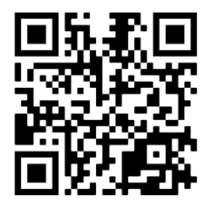
Interested?
Have a look at our website for more insight and apply today.
www.bartonunderneedwood-pc.gov.uk

Qualification Criteria – s.79 Local Government Act 1972
To be nominated as a Candidate a person must meet the criteria listed below:
18 years or over on the day of your nomination
A British, Commonwealth, or Irish Citizen, or a citizen of another Member State of the European Union.

AND at least one of the following:
You must be registered as a voter in the Parish of Barton under Needwood
OR
For 12 months prior to co-option, are Owner or Tenant of any land or premises in the Parish
OR
Your principal or only place of work during those 12 months or more has been in the Parish,
OR
You have lived in the Parish or within 4.8 kilometres (3 miles) during the whole of the 12 months.

3b Disqualification Criteria s.80 Local Government Act 1972
You cannot seek election/co-option if:
- You work for the Parish Council or hold paid office under the Council
- You are the subject of a bankruptcy restrictions order or interim order
- Have been sentenced to a term of imprisonment in the past 5 years
- Have been disqualified under any enactment relating to corrupt or illegal practices.

________________________________________________________________________________

Applications to be considered at the next available meeting until filled. Apply in writing to:
Mrs Siobhan Rumsby, Parish Clerk, Barton under Needwood Parish Council, Village Hall, Crowberry Lane,
Barton under Needwood, DE13 8AF Email: clerk@bartonunderneedwood-pc.gov.uk Tel: 01283 716059

